I hope you enjoyed the program on “Introduction to programming using Scratch”. Now the interesting event is going to start.

PROJECT:

**What should I do?**

**STORY:**

Once upon a time, a man wished to eat fruits. But, he didn’t have money. So he prayed Lord Shiva for the fruit. Lord Shiva appeared and said him that, “I will make “Bananas”, “Orange” and “Apple” appear randomly. If you immediately catch it, you will get the fruits.”

Project:

You have to make 3 fruits(Bananas, Orange, Apple) appear(one at a time) randomly and if you press those fruits you will gate one point on score. Display Score in the background

Your program may look like this:

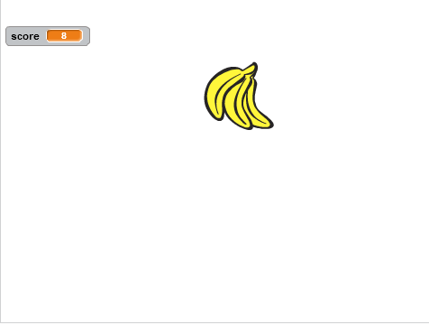

When you press the banana, any other fruit may appear, and score should be updated by 1,

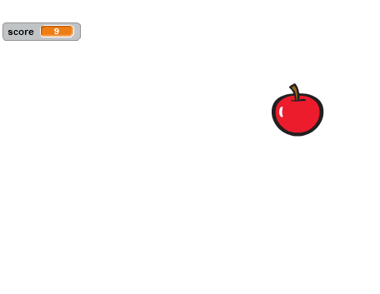

And this should run forever !!!

Interesting, isn’t it?

**You may need some hint!!**

1. You will get photos of Fruits listed above in the new sprites.

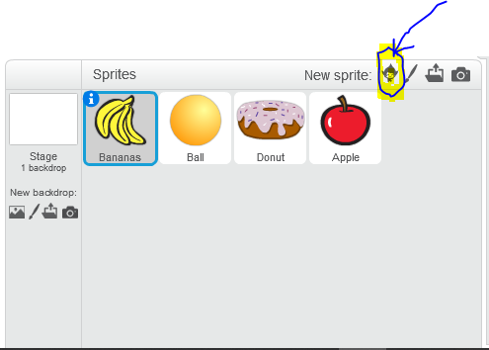

2. You will get ‘show’ and ‘hide’ options for each sprite in scratch which you may need.

3. You can generate random numbers in the section of ‘operators’.

4. Don’t forget the  option to control the program flow.

5. You can store Score as a variable and increment it on press.